BCH/PLS/PPA section exam Feb. 17, 2016 (90 points)

Each question is worth a total of 25 points.

- How does the biosynthesis of ascorbic acid, vitamin C, in plants differ from ascorbic acid biosynthesis in animals that are capable of ascorbic acid synthesis? What is the main role of ascorbic acid and how does it fulfill this role?

- Describe the biosynthesis of sucrose from 3-P-glycerate.

Name the following disaccharides

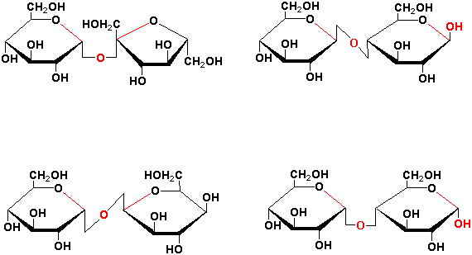

Which are reducing sugars

- Describe the nitrogen (N) cycle including nitrification and denitrification. Include the forms of N that are usually taken up by plants and the formation of the major forms of N utilized in biochemical reactions. What are the main sources of “fixed” nitrogen both in natural ecosystems and in most farmer’s fields in modern agriculture? What were the consequences of reduced nitrate sequestration in root vacuoles reported by Han et al. (2016)?

- Consider that you are hired for a new job after finishing your degree and you are given the task of increasing the oil (triacylglycerol, TAG) content of soybean seeds from 20 to 30% of seed dry weight without changing the protein levels. Normal soybean seeds are 20% TAG, 40% protein, 10% oligosaccharides, 5% minerals (especially phosphate sequestered as a sugar phosphate ester known as phytate, inositol-hexa-phosphate). The remainder is other carbohydrates which does not include starch or fructans. The hydrocarbon that accumulates in soybean seeds like other plant seeds is delivered to the developing seeds in the form of sucrose and amino acids via the phloem. Outline what metabolic steps you would change to achieve the goal of 30% TAG + 40% protein and how they might be changed.

